**Application for Car Pooling System**

**LOW LEVEL DESIGN**

**FLOW CHART FOR MAIN MENU**

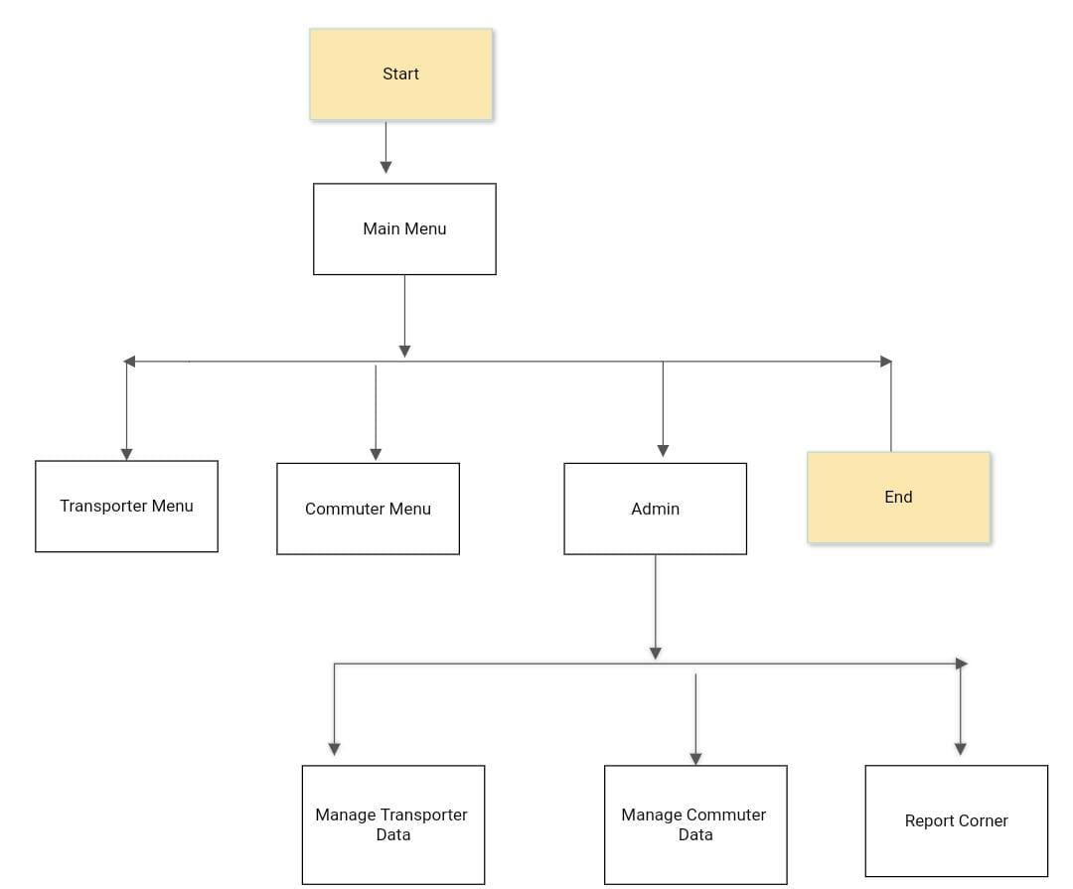

**main menu**: This is the first main menu level function that provides flexibility to enable the commuter and transporter to register using Aadhar card and personal details. Here user can also select the type of module that the commuter and transporter want to open

1) The admin can add, modify or delete the transporter data

2) Admin can add, modify or delete the commuter data.

**FLOW CHART FOR TRANSPORTER**

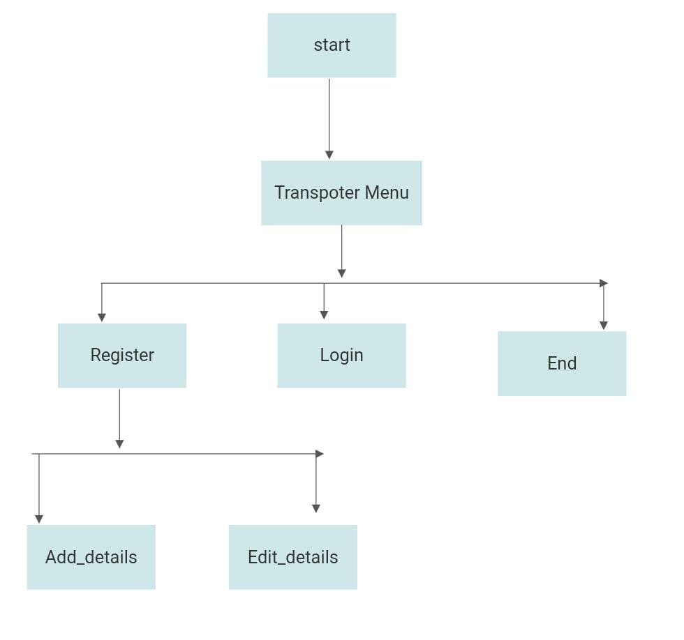

**The Transporter Module**

1) The person who wants to provide the transport service, is required to register on the system with his Driving License number and personal details.

2) Once the registration is done successfully the transporter is provided with a unique-id which is generated by the system.

3) once registration is done transporter allowed to change the personal details only , cannot change the route. Upon his request the admin can do that

**FLOW CHART FOR COMMUTER**

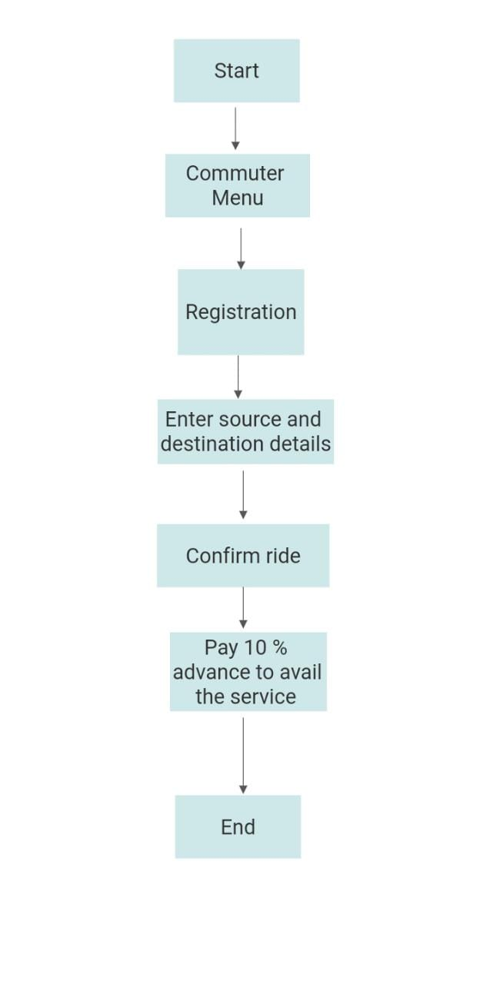

**The Commuter Module**

1) The commuter need to register using his unique adhar no and other personal details.

2) he will be given a confirmation for the same

3) After successfully registration : commuter need to enter his details

**FLOW CHART FOR REPORT CORNER**

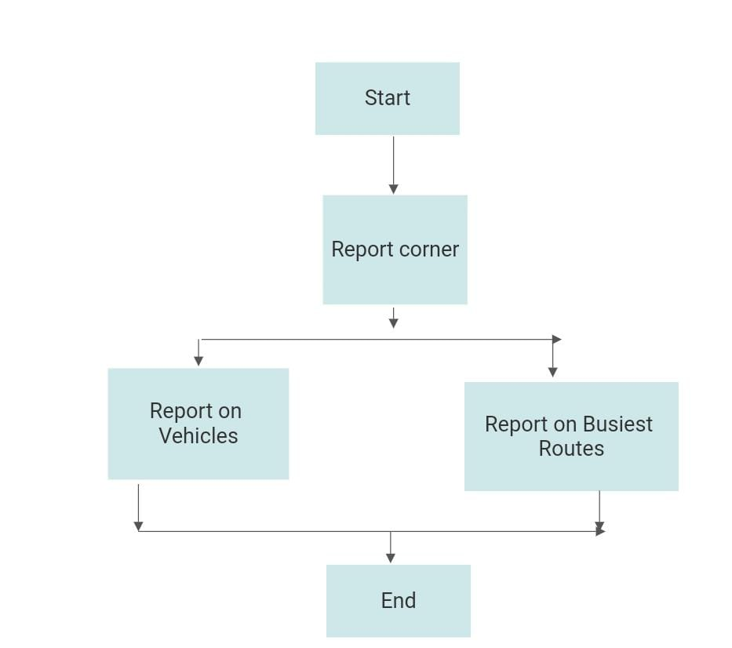

Report

* report containing details of all vehicles for all routes along with respective transporter name should be available.
* A report to show the details of the busiest route in terms of. No of commuter registered for the same is also available.